Ketogenic Adaptation
With Fit Emmett
www.FitEmmett.com
A keto diet is well known for being a low carb diet, where the body produces ketones in the liver to be used as energy. It’s referred to as many different names – ketogenic diet, low carb diet, low carb high fat (LCHF), etc.
When you eat something high in carbs, your body will produce glucose and insulin.
- Glucose is the easiest molecule for your body to convert and use as energy so that it will be chosen over any other energy source.
- Insulin is produced to process the glucose in your bloodstream by taking it around the body.
Since the glucose is being used as a primary energy, your fats are not needed and are therefore stored. Typically on a normal, higher carbohydrate diet, the body will use glucose as the main form of energy. By lowering the intake of carbs, the body is induced into a state known as ketosis.
Ketosis is a natural process the body initiates to help us survive when food intake is low. During this state, we produce ketones, which are produced from the breakdown of fats in the liver.
The end goal of a properly maintained keto diet is to force your body into this metabolic state. We don’t do this through starvation of calories but starvation of carbohydrates.

The State of Ketosis
The state of ketosis means that the body has switched from depending on carbohydrates for energy to burning fats for fuel. This means not only dietary fats (olive oil, guacamole, deep-fried pig ears), but also all the jiggly bits around your waist clearly a desirable state for anyone looking to shed extra weight.
When the body metabolizes fat, it generates molecules called ketones (also known as ketone bodies). As you restrict carbohydrate intake and amp up the dietary fat, more fat is metabolized and a greater quantity of ketones are created. Most of the cells in your body — including those in your brain — are able to use ketones for energy, although many people experience a few days’ adjustment period, often called the low carb flu.

Detecting ketones in urine
The more accurate way and the one I recommend to check for ketosis is by using ketone urine testing strips, often referred to by the brand name Ketostix. These inexpensive testing strips are the perfect solution for instantly checking ketone levels in your urine.
Pass the test end of the small paper strip directly through your urine stream (alternatively, collect urine in a clean, dry container and dip the strip in afterwards). Shake off any excess, then wait 15 seconds. If you’re in ketosis, the strip will change color from its original beige compare the color to the guide on the side of the bottle to find out how “deep” your level of ketosis is.
Deeper purples generally indicate higher levels of ketones. Don’t take this to mean that darker is necessarily better – plenty of people find low-to-mid level ketosis to be a “sweet spot” for linear fat loss and muscle gain while feeling energized.
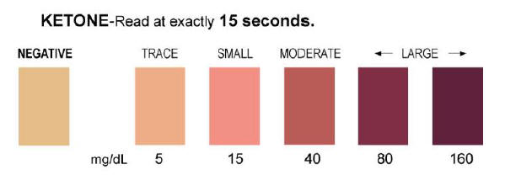

Benefits of Ketogenic Diet

Weight Loss

Control Blood Sugar

Mental Focus

Increased Energy & Normalized Hunger

Epilepsy

Cholesterol & Blood Pressure

Insulin Resistance

Acne

What Do I Eat on a Keto Diet?

To start a keto diet, you will want to plan ahead. That means having a viable diet plan ready and waiting. What you eat depends on how fast you want to get into a ketogenic state. The more restrictive you are on your carbohydrates (less than 15g per day), the faster you will enter ketosis.
You want to keep your carbohydrates limited, coming mostly from vegetables, nuts, and dairy. Don’t eat any refined carbohydrates such as wheat (bread, pasta, cereals), starch (potatoes, beans, legumes) or fruit. The small exceptions to this are avocado, star fruit, and berries which can be consumed in moderation.
Do Not Eat
- Grains – wheat, corn, rice, cereal, etc.
- Sugar – honey, agave, maple syrup, etc.
- Fruit – apples, bananas, oranges, etc.
- Tubers – potato, yams, etc.
Do Eat
- Meats – fish, beef, lamb, poultry, eggs, etc.
- Leafy Greens – spinach, kale, etc.
- Above ground vegetables – broccoli, cauliflower, etc.
- High Fat Dairy – hard cheeses, high fat cream, butter, etc.
- Nuts and seeds – macadamias, walnuts, sunflower seeds, etc.
- Avocado and berries – raspberries, blackberries, and other low glycemic impact berries
- Sweeteners – stevia, erythritol, monk fruit
- Other fats – coconut oil, high-fat salad dressing, saturated fats, etc.
To see more specific advice on what (and what not) to eat You can visit
https://www.ruled.me/ketogenic-diet-food-list/
Use the formula on the link
https://ketogains.com/ketogains-calculator/
Try to remember that keto is high in fat, moderate in protein, and very low in carbs. Your nutrient intake should be something around 70% fats, 25% protein, and 5% carbohydrate.
Typically, anywhere between 20-30g of net carbs is recommended for everyday dieting – but the lower you keep your carbohydrate intake and glucose levels, the better the overall results will be. If you’re doing keto for weight loss, it’s a good idea to keep track of both your total carbs and net carbs.
Protein should always be consumed as needed with fat filling in the remainder of the calories in your day.
You might be asking, “What’s a net carb?” It’s simple really! The net carbs are your total dietary carbohydrates, minus the total fiber. I recommend keeping total carbs below 35g and net carbs below 25g (ideally, below 20g).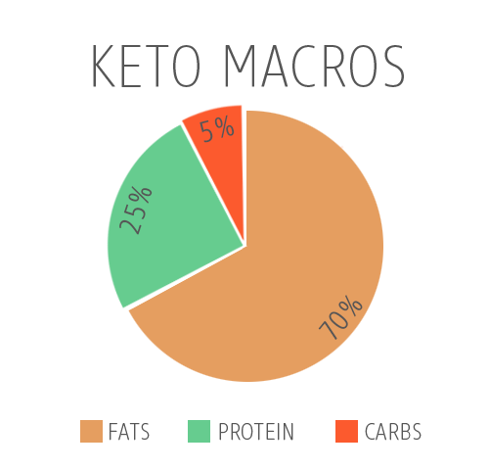
If you’re finding yourself hungry throughout the day, you can snack on nuts, seeds, cheeses, or peanut butter to curb your appetite (though snacking can slow weight loss in the long term). Sometimes we can confuse the want to snack with the need of a meal.

Vegetables on a Ketogenic Diet
Dark green and leafy is always the best choice for vegetables. Most of your meals should be a protein with vegetables, and an extra side of fat. Chicken breast basted in olive oil, with broccoli and cheese. Steak topped with a knob of butter, and a side of spinach sauteed in olive oil.
If you’re still confused about what a net carb is, don’t worry – I’ll explain further. Let’s say for example you want to eat some broccoli (1 cup) – seriously my favorite and most delicious vegetable out there.
- There are a total of 6g carbohydrates in 1 cup.
- There’s also 2g of fiber in 1 cup.
- So, we take the 6g (total carbs) and subtract the 2g (dietary fiber).
- This will give us our net carbs of 4g.
Here’s a list of the most common low carb vegetables.
Vegetable | Amount | Net Carbs
Spinach (Raw) | 1/2 Cup | 0.1
Bok Choi (Raw) | 1/2 Cup | 0.2
Lettuce (Romaine) | 1/2 Cup | 0.2
Cauliflower (Steamed) | 1/2 Cup | 0.9
Cabbage (Green Raw) | 1/2 Cup | 1.1
Cauliflower (Raw) | 1/2 Cup | 1.4
Broccoli (Florets) | 1/2 Cup | 2
Collard Greens | 1/2 Cup | 2
Kale (Steamed) | 1/2 Cup | 2.1
Green Beans (Steamed) | 1/2 Cup | 2.9

Good Luck

